HW 09

DWBI

Shivam Verma

SQL script for table:

create table test (id char(5))

insert into test values ('ca-1')

insert into test values ('ca-2')

insert into test values ('ca-3')

insert into test values ('ca-4')

insert into test values ('ca-5')

insert into test values ('ca-10')

insert into test values ('ca-20')

select \* from test order by 1

Screenshot of table:

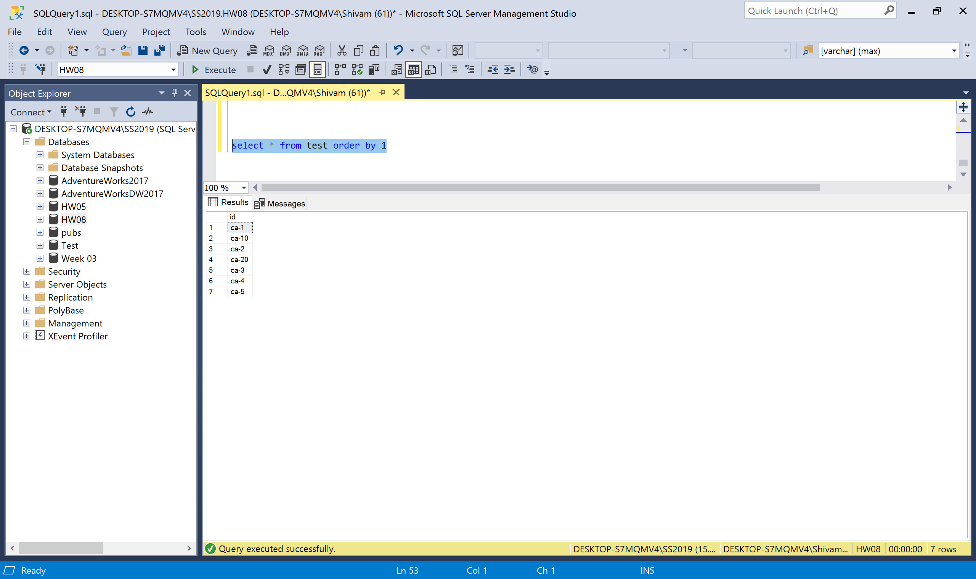

SQL command for padding id with 0:

Select Case

When SUBSTRING(id,4,5) < 10 then left(id,3) + '0' + SUBSTRING (id, 4, 5)

else id

end as id

from test order by 1

Screenshot of table with new id:

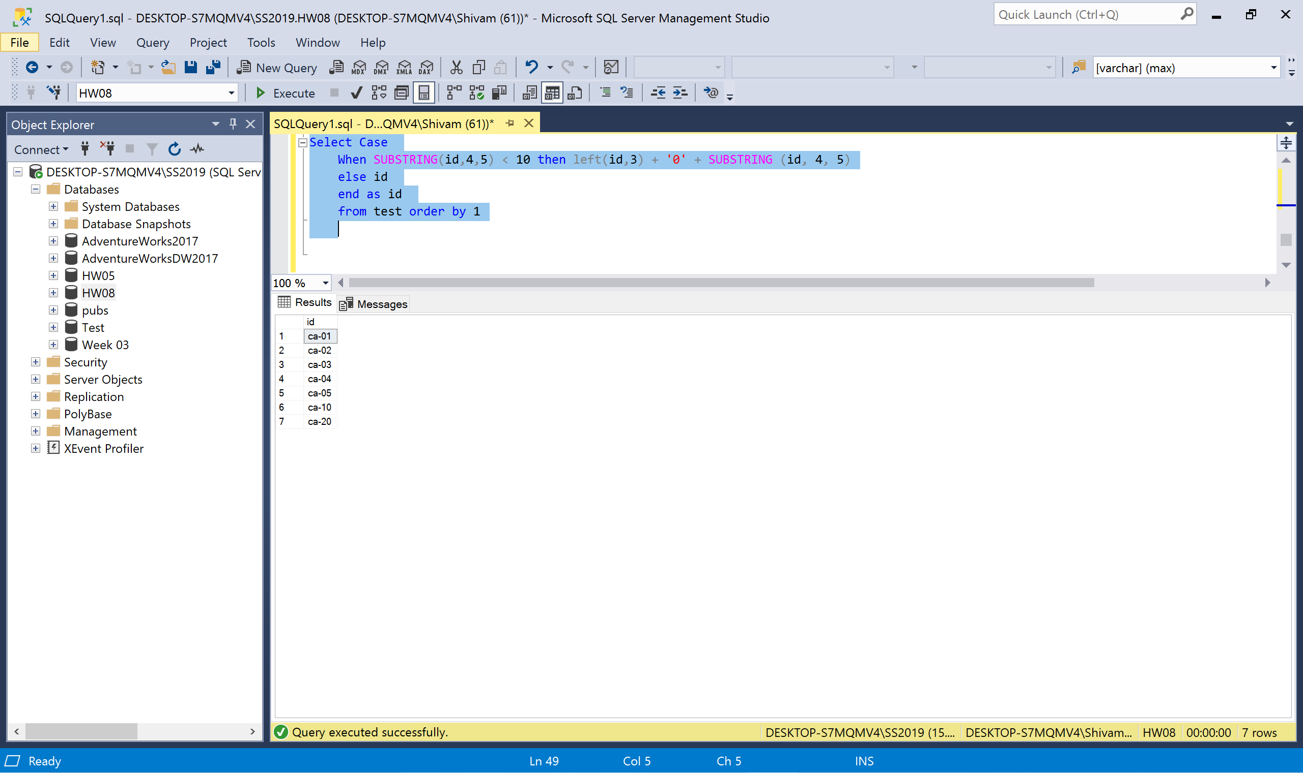

Screenshot of data flow:

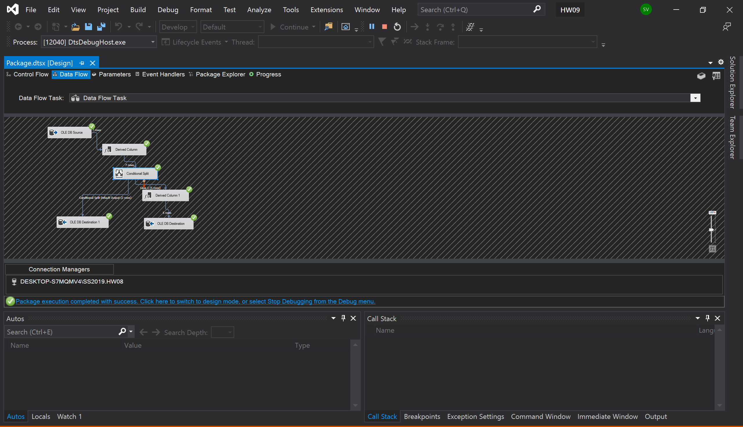

Screenshot of destination table with new id:

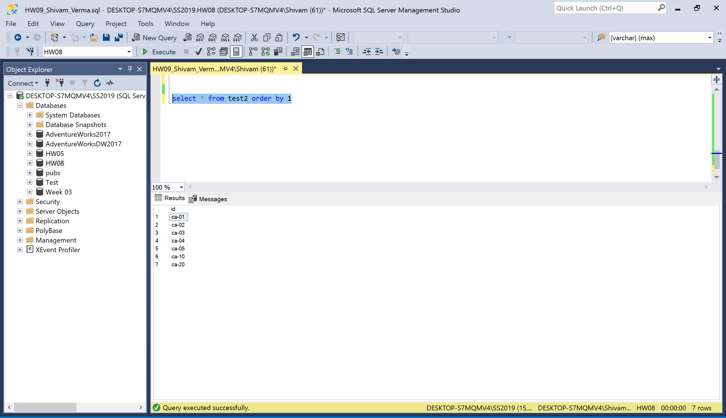

Screenshot of source:

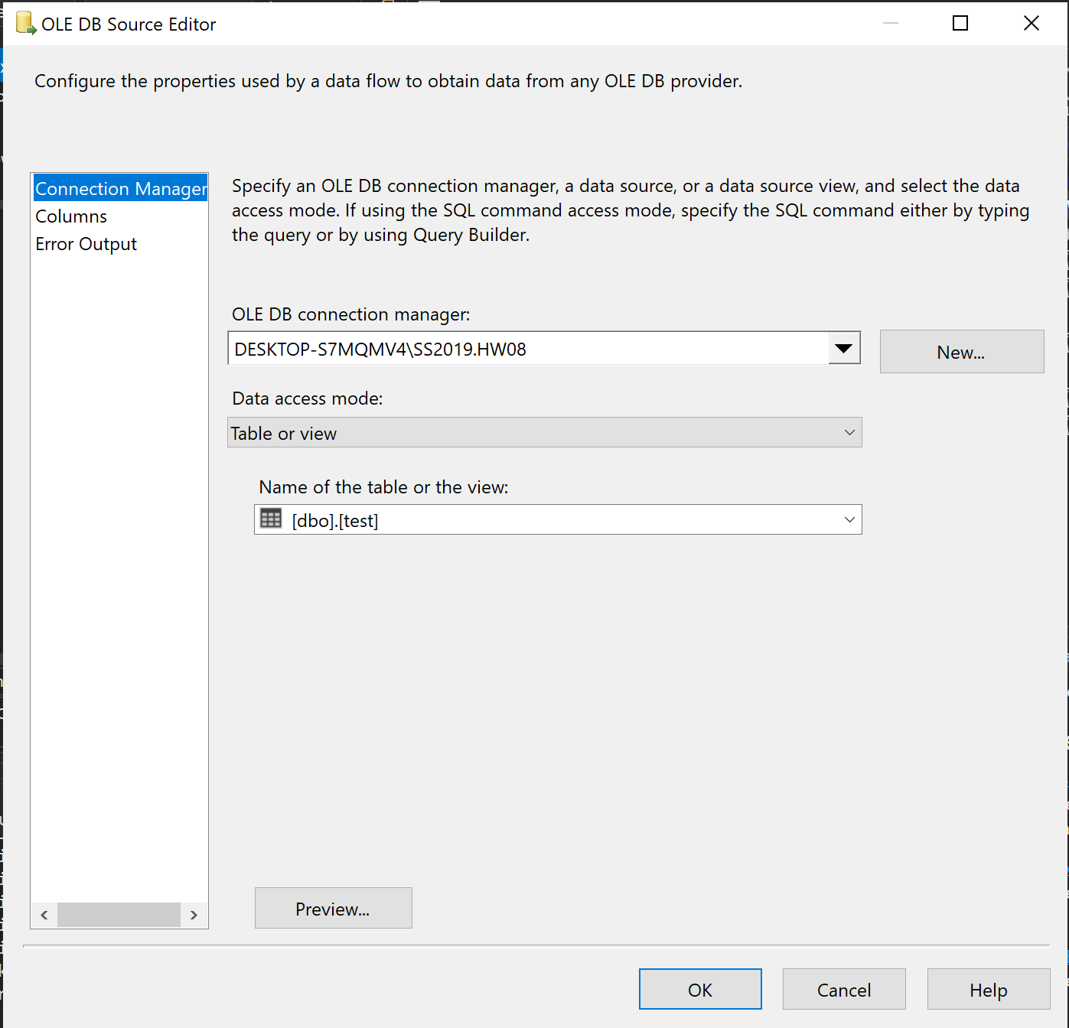

Screenshot of derived column:

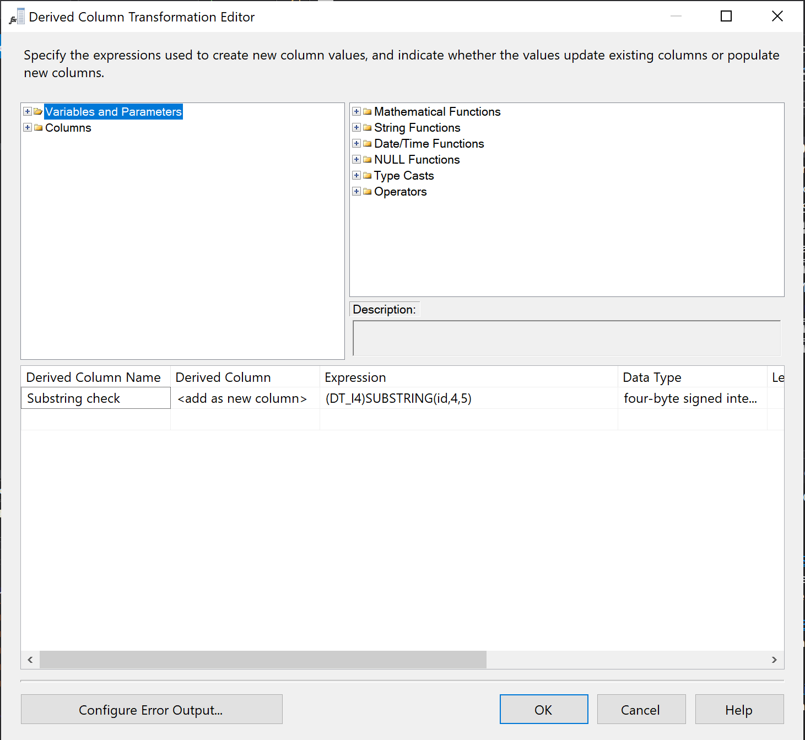

Screenshot of conditional split:

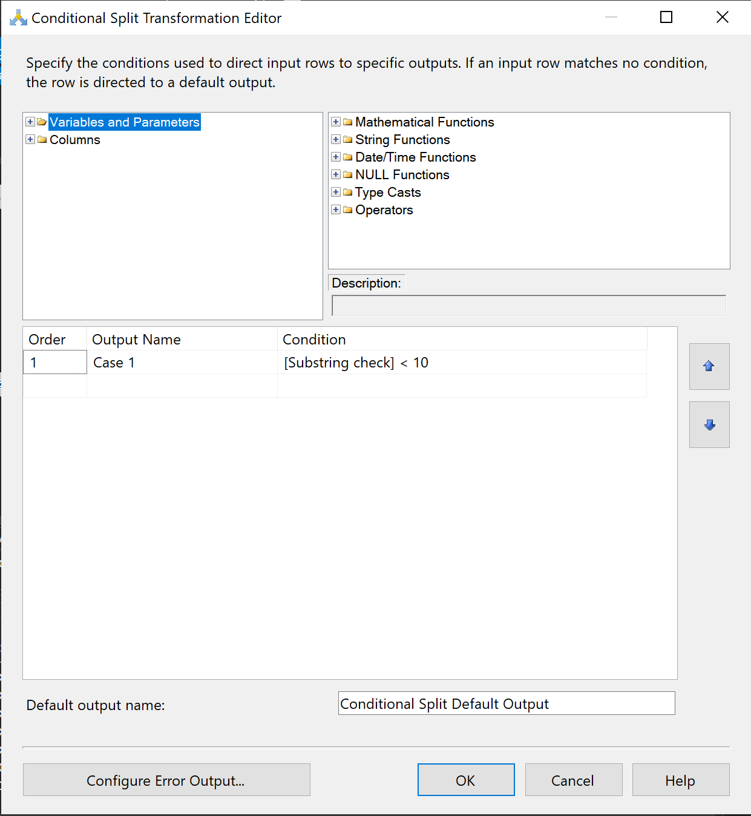

Screenshot of derived column1:

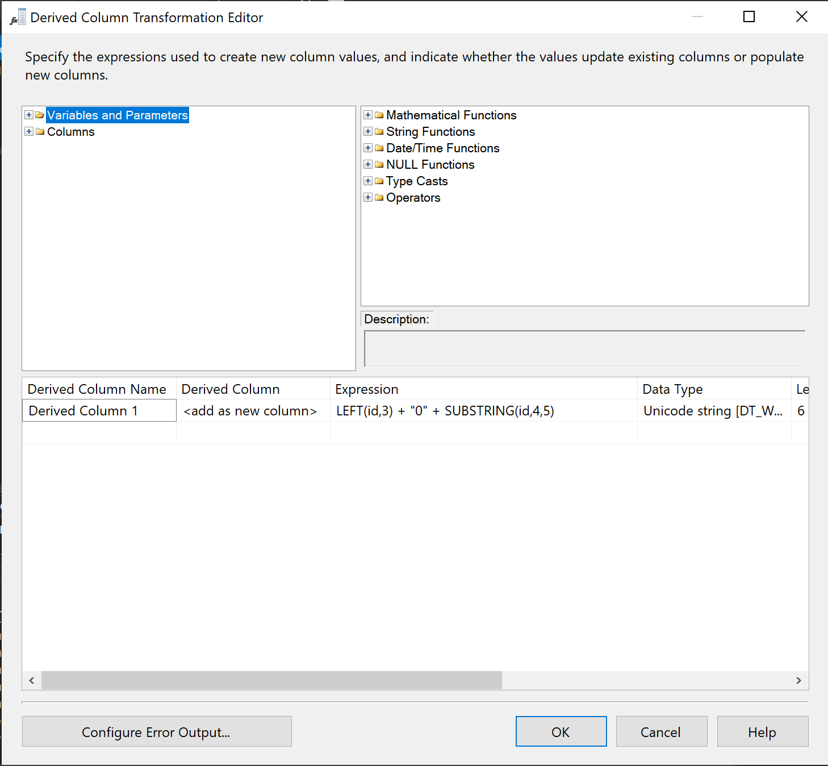

Screenshot of Destination:

